**How to Draw a Shark!**

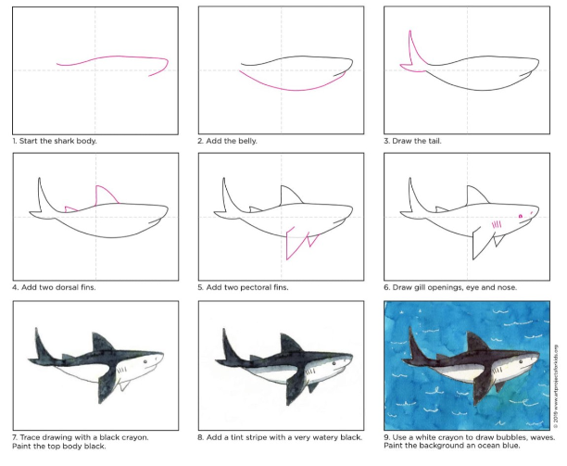

**Remember to send us a picture of your finished art work! ☺**