French counting challenge!

- Below you’ll find a mixture of active and counting challenges!

- Choose which ones you would like to try and count each one in French as you are doing it.

- Add your total number the boxes below.

- Share your counting with your family, teachers and with us! #FrenchCountingChallenge

- You can use the Youtube videos on our site to help you practice!

Saute à la | Compte les | Compte
corde! | voitures dans la | des
 | rue | arbres
Compte | Rebondi | Fais la planche
des | une balle
oiseaux
Joue à la | Fais des | Fais des
marelle | “keepie | sautes
 | uppies!” | d’étoile
Pose | Danse le floss | Compte les
comme |  | insectes
un
arbre

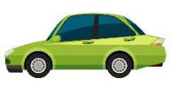

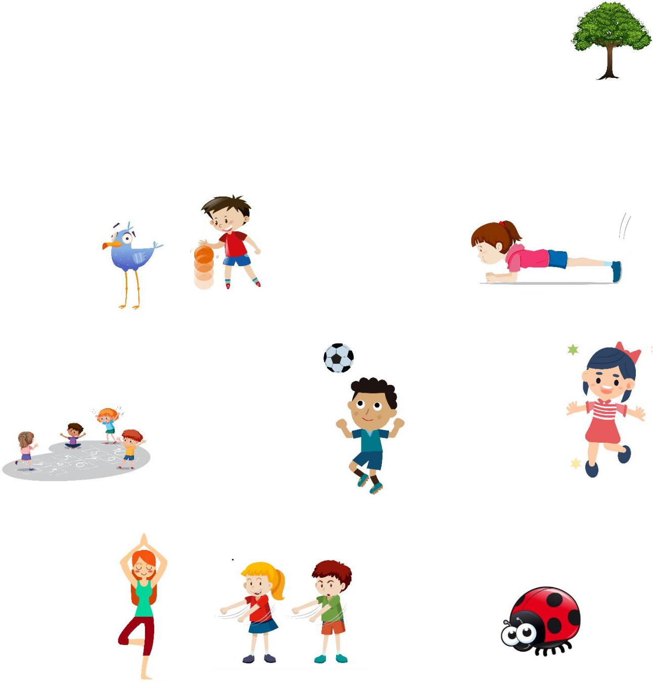
French | English | Notes
Saute à la corde | Skip | You can do this using a
 |  | skipping rope or just skipping!
Compte les | Count the cars | Count the cars you can see
voitures dans la | in the street | parked or which pass
rue
Compte des arbres | Count trees | Count the trees you see on a
 |  | walk, in your garden or
 |  | around your house!
Compte des | Count birds | Pick a location and watch for
oiseaux |  | a set time, how many birds
 |  | can you see?
Rebondi une balle | Bounce a ball | Bounce a ball as many times
 |  | as you can. Count in French
 |  | as you’re doing it and note
 |  | your highest score!
Fais la planche | Do a plank | Hold it for as long as you can
 |  | and count in French!
Joue à la marelle | Play hopscotch | Make a hopscotch grid
 |  | outside and say the numbers
 |  | in French as you play!
Fais des “keepie | Do some keepie | Do as many as you can and
uppies” | uppies1 | count them up in French as
 |  | you go!
Fais des saute | Do some star | Do as many as you can and
d’étoiles | jumps | count them in French as you
 |  | go!
Pose comme un | Do a yoga tree | Hold it for as long as you can
arbre | pose | and count in French!
Danse le floss | Dance the floss | Do as many flosses as you
 |  | can and count them in
 |  | French. Switch to other
 |  | dances if you know them!
Compte les | Count insects | Do a minibeast count. In an
insectes |  | area outside, see how many
 |  | insects you can find and note
 |  | your numbers in French.

0 | zéro | 10 |  | dix | 20 | vingt |  | 30 |  | trente
1 | un | 11 |  | onze | 21 | vingt et un |  | 31 |  | trente et un
2 | deux | 12 |  | douze | 22 | vingt-deux |  | 32 |  | trente-deux
3 | trois | 13 |  | treize | 23 | vingt-trois |  | 33 |  | trente-trois
4 | quatre | 14 |  | quatorze | 24 | vingt-quatre |  | 34 |  | trente-quatre
5 | cinq | 15 |  | quinze | 25 | vingt-cinq |  | 35 |  | trente-cinq
6 | six | 16 |  | seize | 26 | vingt-six |  | 36 |  | trente-six
7 | sept | 17 |  | dix-sept | 27 | vingt-sept |  | 37 |  | trente-sept
8 | huit | 18 |  | dix-huit | 28 | vingt-huit |  | 38 |  | trente-huit
9 | neuf | 19 |  | dix-neuf | 29 | vingt-neuf |  | 39 |  | trente-neuf
40 | quarante | 50 | cinquante |  | 60 | soixante | 70 |  | soixante-dix
41 | quarante et un | 51 | cinquante et un |  | 61 | soixante et un | 71 |  | soixante-onze
42 | quarante-deux | 52 | cinquante-deux |  | 62 | soixante-deux | 72 |  | soixante-douze
43 | quarante-trois | 53 | cinquante-trois |  | 63 | soixante-trois | 73 |  | soixante-treize
44 | quarante-quatre | 54 | cinquante-quatre |  | 64 | soixante-quatre | 74 |  | soixante-quatorze
45 | quarante-cinq | 55 | cinquante-cinq |  | 65 | soixante-cinq | 75 |  | soixante-quinze
46 | quarante-six | 56 | cinquante-six |  | 66 | soixante-six | 76 |  | soixante-seize
47 | quarante-sept | 57 | cinquante-sept |  | 67 | soixante-sept | 77 |  | soixante-dix-sept
48 | quarante-huit | 58 | cinquante-huit |  | 68 | soixante-huit | 78 |  | soixante-dix-huit
49 | quarante-neuf | 59 | cinquante-neuf |  | 69 | soixante-neuf | 79 |  | soixante-dix-neuf
80 quatre-vingts |  | 90 quatre-vingt-dix |  |  |  |  | 100 |  | cent
81 quatre-vingt-un |  | 91 quatre-vingt-onze |  |  |  |  | 101 |  | cent-un
82 quatre-vingt-deux |  | 92 quatre-vingt-douze |  |  |  |  | 102 |  | cent-deux
83 quatre-vingt-trois |  | 93 |  | quatre-vingt-treize |  |  | 200 deux cents
84 quatre-vingt-quatre |  | 94 |  | quatre-vingt-quatorze |  |  | 202 deux-cent-deux
85 quatre-vingt-cinq |  | 95 |  | quatre-vingt-quinze |  |  | 300 trois cent
86 quatre-vingt-six |  | 96 quatre-vingt-seize |  |  |  |  | 500 cinq cent
87 quatre-vingt-sept |  | 97 quatre-vingt-dix-sept |  |  |  |  | 1000 |  | mille
88 quatre-vingt-huit |  | 98 quatre-vingt-dix-huit |  |  |  |  | 200 |  | deux-mille
89 quatre-vingt-neuf |  | 99 |  | quatre-vingt-dix-neuf |  |  | 1000000 |  |  | un million

