Home Learning Grids - P3, P4 & P5
Each day, choose 1 literacy and 1 numeracy task and either 1 expressive arts/STEM challenge OR 1 from the separate P.E. challenge grid. If you choose an expressive arts/STEM challenge on day 1, make sure you choose a P.E. challenge on day 2 or vice versa. If you are looking for additional things to keep you busy- attempt the challenges added to several tasks and see the list of additional activities below.

Week 1
Literacy | Numeracy | Expressive Arts/STEM
Design a Starbucks Smoothie-  Starbucks want you to design a new smoothie for their Autumn/Winter collection. Write the recipe-  - List the ingredients  - Method- how do you  make it?  - Draw a picture of  what it will look  like. | Topmarks Bingo Game-  Choose a times table you find tricky. Play Topmarks Bingo- Multiplication & Division for 20 minutes or until you feel more confident with the answers. Could you challenge a family member to play with you?  https://www.topmarks.co.uk/  *Challenge- choose another multiplication game to play.* | Family Movie Night-  Plan a family movie night. Design a poster to advertise the movie. Add the date, time and location of the movie. Display it somewhere your family will see it, i.e. on the fridge.  *Optional- prepare the movie area and some snacks for family members.*
Job Application Task-  What is your dream job? Create a CV.  Tell us why this is your dream  job, why you should get it,  list your skills and qualities  and why you are suitable for  this job. | Sumdog-  Spend 30 minutes on Sumdog- if your teacher has set your class a challenge, complete this first. If not, choose your own games!  https://pages.sumdog.com/ | Arty Food Task-  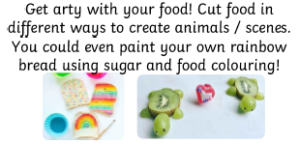
Literacy | Numeracy | Expressive Arts/STEM
Question Master  Create 5 questions about the book you are currently reading (either personal or class novel). Start each question with why, what, where, when & how. | Estimation Activity-  - Estimate how tall each person in your house is in cm.  - Estimate how long it takes to do 30 star jumps in seconds.  - Check both answers using a measuring tape and timer if you have them- how many cms/seconds were you away from the real answer?  *Challenge- convert answers to metres and centimetres/minutes and seconds.* | Spaghetti Bridge STEM-
Isolation Interview-  Interview someone you know- they could live with you or you could phone them. Questions could include:  - What have you had to change about your life in the last few months?  - Do you have any new hobbies?  - What do you miss most?  - Have you learned any important life lessons?  If you like, you could record your interview and share on Seesaw.  *Challenge- think of your own additional questions to ask.* | Money Chilli Challenge-  Start with the green chilli challenges then try the orange ones.  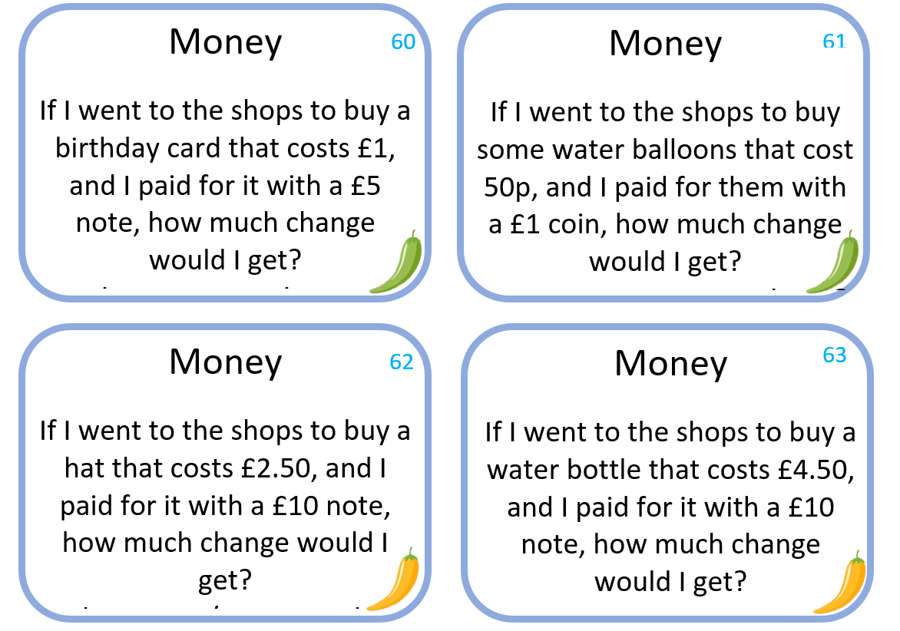 | Word Art  Go to https://wordart.com/ and create a word art picture filled with compliments for someone that means a lot to you.  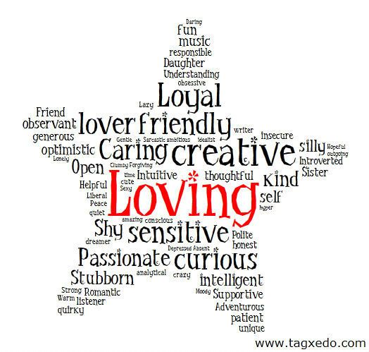
Literacy | Numeracy | Expressive Arts/STEM
You’ve Got a Friend in Me-  Write a postcard to your best friend. What do you want to tell them? What questions would you like to ask them?  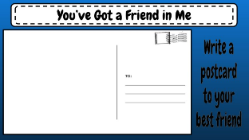 | Rounding Activity-  Go as far as you can in this challenge.  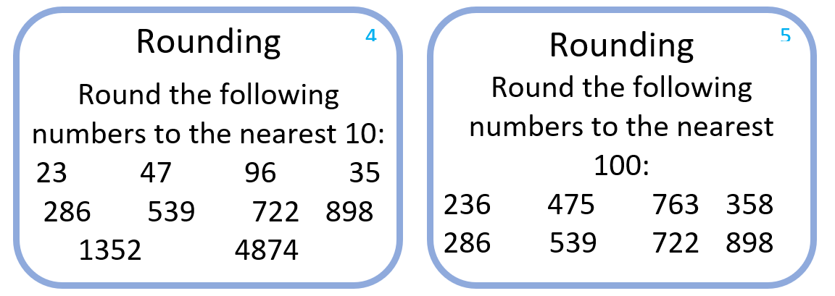 | Freezing Liquids Activity-  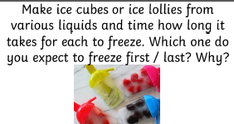
*Remember to try to complete a minimum of 20-30 minutes of personal reading per day. If you don’t have any books at home, try reading magazines, cookbooks, comics or online books.
For additional activities:
All children have a log in for Bug Club which develops reading and comprehension skills (ask your child’s teacher if they don’t know their log in) https://www.activelearnprimary.co.uk/login?c=0
Oxford Owls have a library of free books: https://www.oxfordowl.co.uk/
Free audiobooks for children: https://www.storynory.com/
Lots of free maths games: https://www.topmarks.co.uk/
Daily lessons in literacy, numeracy and health and wellbeing: https://www.bbc.co.uk/bitesize
Learn, create and play through exploring Scotland’s history and heritage: https://www.historicenvironment.scot/learn/
STEM (Science, Technology, Engineering & Maths) with Mr N: https://www.youtube.com/channel/UCxziq4omrQP-EKSLilOIPhw
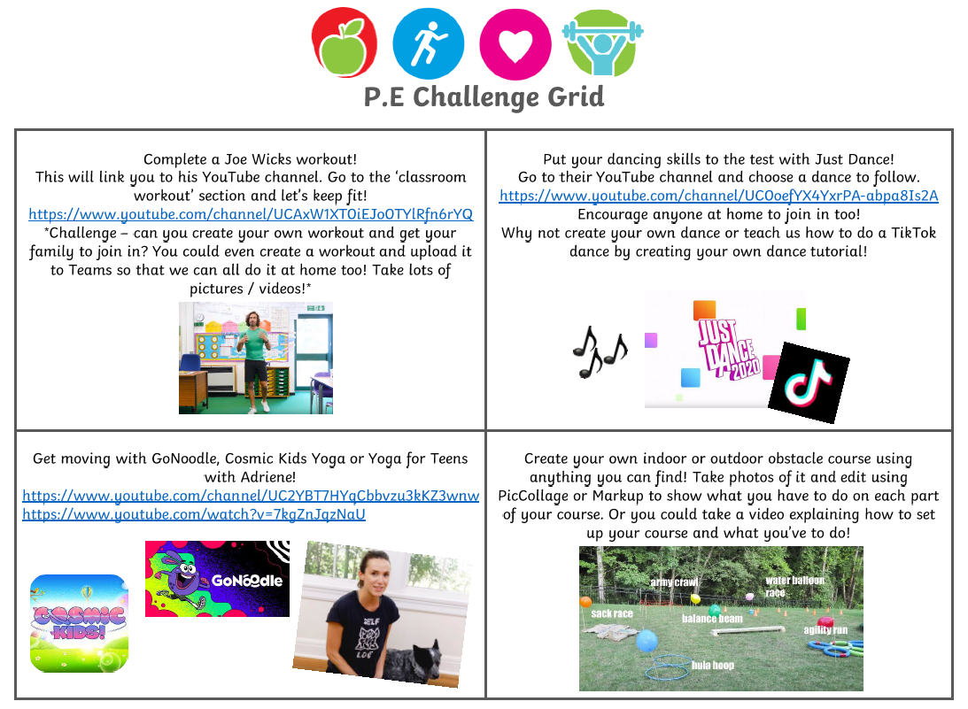
Week 2
Literacy | Numeracy | Expressive Arts
Poetry Task-  Listen to a poem on:  https://childrens.poetryarchive.org/  Three Sharings:  - What did you like/dislike about the poem?  - Any connections you can make to your own life?  - Puzzles- anything that confused you?  *Challenge- record yourself reciting the poem. Have a go at writing your own with the same title but your own words!* | Education City-  Spend 45 minutes on Education City- if your teacher has set your class a challenge on My City, complete this first. If not, choose your own games!  https://educationcity.com/ | Kitchen Roll Art-  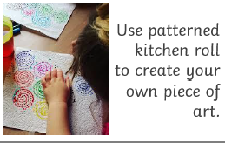
Research Project: Favourite Animal-  Choose an animal that you love and want to find out more about. Create a fact sheet (handwritten or typed on Word)  - Describe this animal  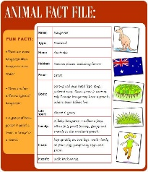  - What do they eat?  - What is their habitat like?  - What is their lifespan?  - Fun facts about this animal  *Challenge- film a David Attenborough-style nature documentary, telling your viewers all about this animal.* | Counting in 2s, 5s, 10s & 100s-  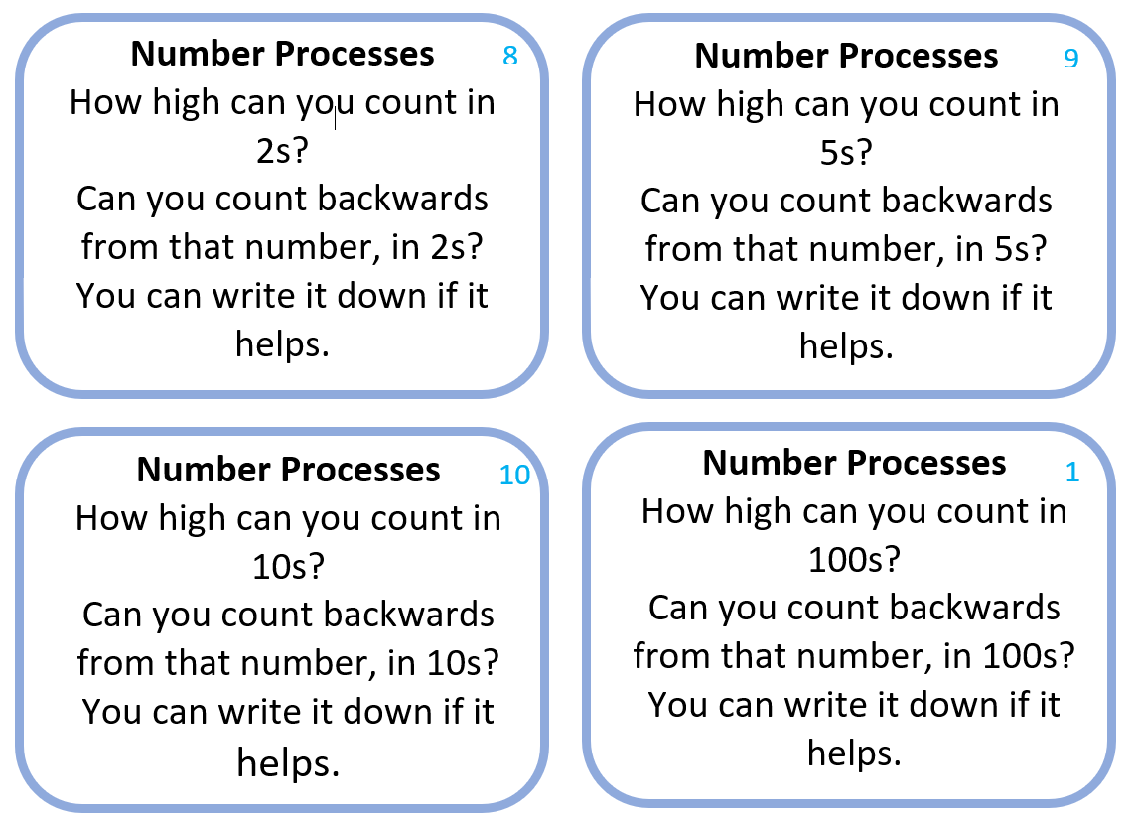 | Blanket Fort-  Design and create your own blanket fort. Take a picture and share it on Seesaw.  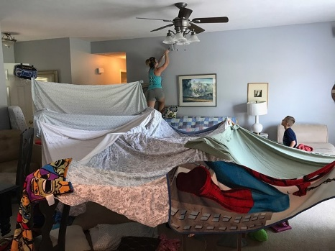
Literacy | Numeracy | Expressive Arts/STEM
Design a New Toy-  - List the materials your toy will be made of, e.g. wood, plastic, etc.  - Who is the toy for? E.g. babies, age 7-10 year olds, etc.  - Describe how you play with the toy.  Record your design and details on a piece of paper. | Topmarks-  Play Hit the Button Division Facts (divide by 1, 2 & 3)  https://www.topmarks.co.uk/maths-games/hit-the-button  *Challenge- try divide by 4 & 5.* | Cereal Box STEM Challenge-
Newspaper Challenge-  Using a newspaper, magazine or a book find words that you don’t know the meaning to. Write them down and use a dictionary (online dictionary is fine) to find a definition for them. | Seasons Activity-  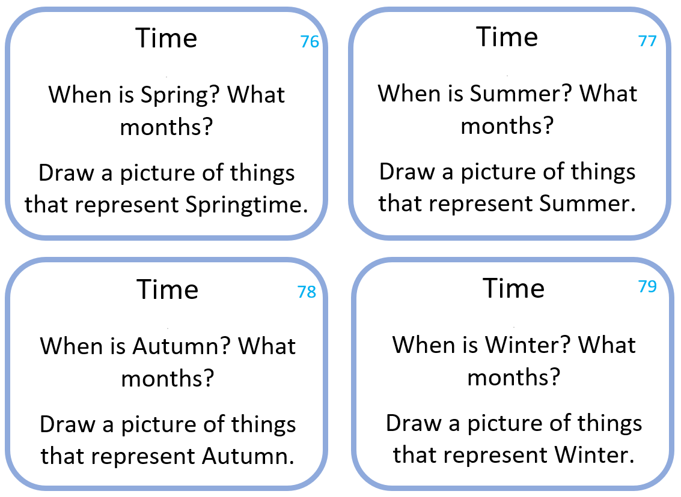 | Origami Activity-  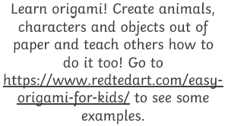  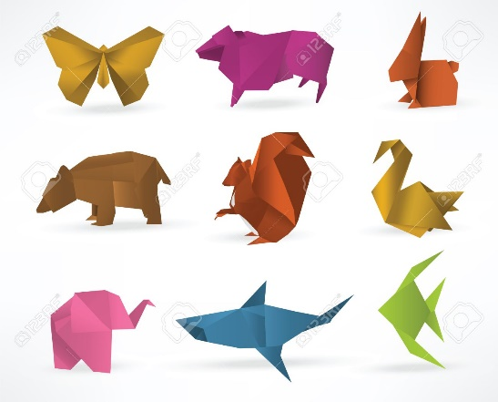
Literacy | Numeracy | Expressive Arts/STEM
ABC Order-  Write the words you used in your newspaper challenge out in alphabetical order. Then write them in reverse alphabetical order.  Word Search-  Create your own word searches using your words. Or use this link to get your computer to do it for you.  http://puzzlemaker.discoveryeducation.com/ | Number Processes Chilli Challenge-  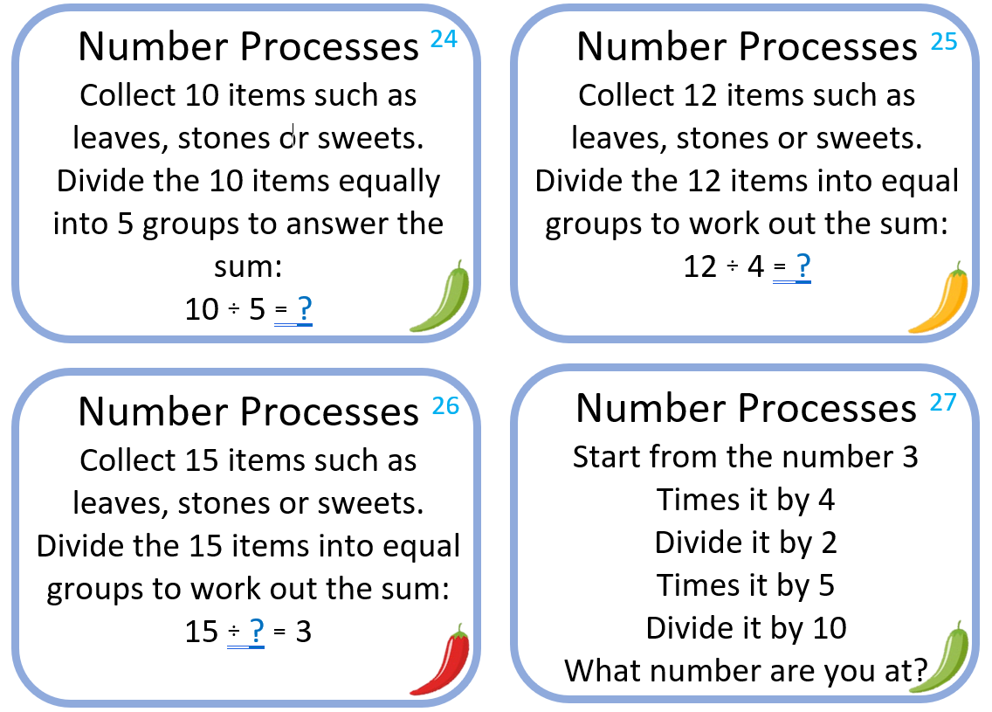 | Coding Challenge-  Go to https://code.org/learn and choose a coding activity to complete. My personal favourite is the Minecraft Hour of Need one.  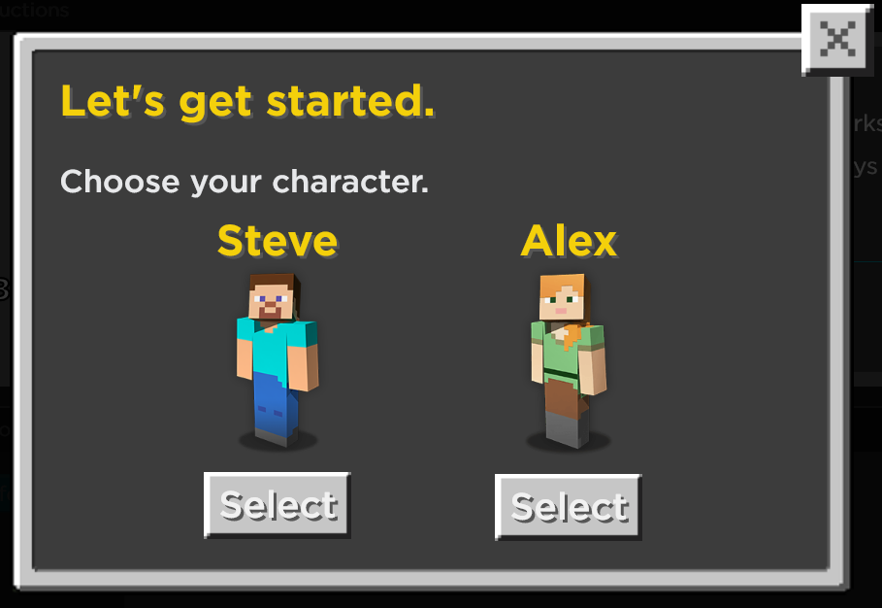
*Remember to complete a minimum of 20-30 minutes of personal reading per day. If you don’t have any books at home, try reading magazines, cookbooks, comics or online books.
For additional activities:
All children have a log in for Bug Club which develops reading and comprehension skills (ask your child’s teacher if they don’t know their log in) https://www.activelearnprimary.co.uk/login?c=0
Oxford Owls have a library of free books: https://www.oxfordowl.co.uk/
Free audiobooks for children: https://www.storynory.com/
Lots of free maths games: https://www.topmarks.co.uk/
Daily lessons in literacy, numeracy and health and wellbeing: https://www.bbc.co.uk/bitesize
Learn, create and play through exploring Scotland’s history and heritage: https://www.historicenvironment.scot/learn/
STEM (Science, Technology, Engineering & Maths) with Mr N: https://www.youtube.com/channel/UCxziq4omrQP-EKSLilOIPhw
