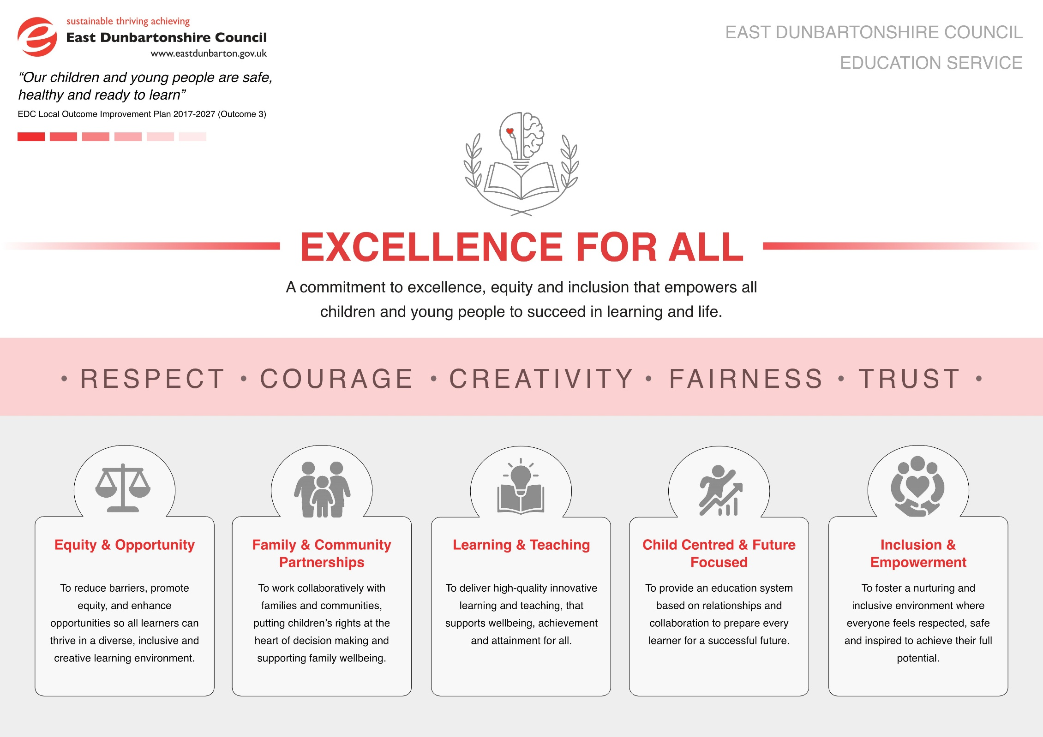
Section 1: School Information and 3 Year Improvement Plan Priorities
School/Establishment | Gartconner Primary School
Head Teacher | Lynne McGoldrick
Link QIO | Vicky MacKenzie

School Statement: Vision, Values & Aims and Curriculum Rationale
Link to school website.
Current Standards & Quality Report
Link to school website and/or SWAY.

Looking Forwards – 3 Year Improvement Plan Priorities
Bullet point key priorities for the next 3 years
Session | 2026/27 | 2027/28 | 2028/29
Priority 1 | Wellbeing & Inclusion | Wellbeing & Inclusion | Wellbeing & Inclusion
Priority 2 | Pedagogy & Meta-Skills | Curriculum  - CIC Implementation Planning  - 21 Hours | Pedagogy  - CIC Implementation

Section 2: Improvement Priority 1
School/Establishment | Gartconner Primary
Improvement Priority 1 | Wellbeing & Inclusion
Strategic Leads | Lynne McGoldrick HT  Emmaline Ferris ADHT  Julie Cameron APT  Katie Gilmour & Loren Rolinska PEF PT
Education Service Aim |  | IMAGINE Leadership Strategy | NIF Priority | HGIOS 4 QIs
Delete / copy as required  Inclusion & Empowerment |  | Delete / copy as required  Priority 6: Wellbeing & Inclusion  Choose an item.  Choose an item. | Delete / copy as required  Placing the human rights and needs of every child and young person at the centre  Improvement in children and young people’s health and wellbeing  Choose an item. | Delete / copy as required  QI 3.1 Wellbeing, equality & inclusion  QI 3.2 Raising attainment and achievement  Choose an item.

Opportunities for Leadership | Resource Requirements | Parental Engagement and Involvement
Community Focused Learning Lead - PEF PT and supported by families and children  Emotional and mental curricular Lead – PT  Social Media safety – DHT & Parent Council  Dyslexia lead –SLT & supported by CTs | Hamish & Milo programme  Dyslexia resources  New Roots service | Termly Sway  Termly update to parent council  Electronic surveys  Community working group
Professional Learning | Interventions for Equity | Pupil Equity Funding (PEF) Allocation
Curriculum Development sessions  Enquiry based learning – Dyslexia  Professional reading | Delete / copy as required  social & emotional wellbeing | Hamish & Milo  Games to support health & wellbeing  Sensory circuit equipment  Reading for Enjoyment Big Books  Alternative Curriculum resources  Fruits/cereal/milk/bread  Microwave  Toaster

Outcomes/Expected  Impact for learners | Tasks/Interventions | Measures | Timescale(s) | Progress to date
consider targets, % change expected | Activities in Working Time Agreement, Professional Learning  Learning and Teaching interventions | What ongoing information will demonstrate progress? Identify qualitative, quantitative, evaluative pre and post measures | What are the key dates for implementation? When will outcomes be measured? | Termly update
To universally embed strategies and tools to create an inclusive classroom for almost all learners | Open University  Dyslexia Scotland  Module 1 – Introduction to Dyslexia and Inclusive Practice  30 September 2026 1.5 hours  6 October 2026 1.5 hours | Pre and post measure of teacher/learner knowledge and understanding  Ongoing assessment for staff  Final assessed quiz | August 2026 – ongoing throughout session 26/27.
To improve emotional literacy, resilience and social connectedness for all learners within targeted groups. | Exposure to Hamish & Milo  program for all staff  20 January 2027 1.5 hours  PEF PT to implement  - 10 week therapeutic play groups focusing on self-regulation and communication skills | Pre and post assessment  - Monitor number of classroom escalations  - Track changes in ability to execute tasks  - Rubric for observations and self-assessment of attitude | August 2026 – ongoing throughout session 26/27.
For almost all children to be able to make informed choices about online health. | Working party focus group of parents, learners and staff  Task - Develop How to stay Healthy Online policy (with contract)  Assemblies/Class lessons/Parent Guide/Community café sharing/displays  Consider  - Lifestyle and posture  - Vision  - Fatigue & stress  - Sleep – bedtime routines  - Social isolation  - Focus  - Algorithms  - Fake news – AI  - Mainstreaming of niche, subcultural or abnormal concepts  - Desensitisation  In-service day 4  Task – develop lessons/resources to support online health at Early/First/Second level

Section 2: Improvement Priority 2
School/Establishment | Gartconner Primary
Improvement Priority 2 | Pedagogy & Meta-Skills
Strategic Leads | Lynne McGoldrick HT  Emmaline Ferris ADHT  Julie Cameron APT  Katie Gilmour & Loren Rolinska PEF PT

Education Service Aim | IMAGINE Leadership Strategy | NIF Priority | HGIOS 4 QIs
Delete / copy as required  Learning & Teaching | Delete / copy as required  Priority 2: Learning & Teaching  Choose an item.  Choose an item. | Delete / copy as required  Improvement in achievement, particularly in literacy and numeracy.  Closing the attainment gap between the most and least disadvantaged children  Choose an item. | Delete / copy as required  QI 2.3 Learning, Teaching & Assessment  QI 1.3 Leadership of Change  Choose an item.

Opportunities for Leadership | Resource Requirements | Parental Engagement and Involvement
Led by PTs and class teachers supported by SLT  Children leading their own learning thorough the school | Play and enquiry resources outdoor  Play and enquiry resources indoor | Areas of provision set up for community cafes  Weekly updates via Seesaw  Termly updates Via Sway
Professional Learning | Interventions for Equity | Pupil Equity Funding (PEF) Allocation
Clear understanding of effective play based pedagogy  Layout of classroom environments  Delivering a balance of approach: teacher led, adult initiated, child led.  Creating high quality provocations to engage in meaningful learning experiences, developing meta skills and extending thinking  observations (teachers judgement/ progress/ next steps)  Collegiate meetings delivered by PT and DHT on Meta Skills, Provocations and Planning.  Staff peer observations of teaching and learning and learning walks to showcase area of provision in all classrooms.  Collegiate meetings led by staff | Delete / copy as required  high quality learning experience | Play & Enquiry Resources  Supply cover

Outcomes/Expected  Impact for learners | Tasks/Interventions | Measures | Timescale(s) | Progress to date
consider targets, % change expected | Activities in Working Time Agreement, Professional Learning  Learning and Teaching interventions | What ongoing information will demonstrate progress? Identify qualitative, quantitative, evaluative pre and post measures | What are the key dates for implementation? When will outcomes be measured? | Termly update
Enhance and embed a consistent whole-school play based approach and shared language for meta skills to ensure coherence and progression across Primary 1–7.  Strengthen staff confidence in explicitly modelling and reinforcing meta skills within play based and all other learning opportunities. | PT will lead collaborative professionalism sessions on Meta skills, focussing on the Meta Skills progression framework (Early – Second Level).  19 August 2026 1.5 hours  Coaching and mentoring approaches to support staff in embedding play based teaching and learning.  Consistent use of Meta Skills Land (P1-3) AND Meta Skills (P4-7) displayed in classrooms and learning environments.  Targeted CLPL on effective modelling, scaffolding and effective questioning techniques through spotlighting.  25 August 2026 1.5 hours  Staff will work collaboratively to complete new planning template to reflect adult led, child led, and adult initiated learning experiences.  Week beginning  14 September 2026 1 day  11 January 2027 1 day  26 April 2027 1 day  Staff will be signposted to EDC Professional Learning sessions for Play to Learn. | Peer observations and learning walks focussed on areas of provision and meta skills in practice.  3 February 2027 1.5 hours  Infant Walks  9 February 2027 1.5 hours  Upper walks  Learning conversations with children.  Professional dialogue during Data Informed Planning Meetings.  Staff evaluations will inform next steps/changes/strengths across the school.  Impact & Evaluation session  30 March 2027 1.5 hours | August 2026 – ongoing throughout session 26/27.
Increase planned opportunities for learners to identify, discuss and reflect on their use of meta skills, particularly through learning conversations and reflection booklets.  P1-2 teachers will conduct high quality observations to understand engagement and involvement during child led play experiences. | Staff will engage in observation CLPL to conduct quality observations and formally document children’s play and learning using tools such as the Leuven Scale to assess involvement and engagement, capture interests and learning, and use this evidence to plan intentional next steps that extend and deepen learning.  Each child in P1-2 will have an in-depth observation recorded across various areas of continuous provision focussing on engagement, involvement, interests and meta skills.  8 September 2026 1.5 hours | Children will use reflection booklets appropriate to their age and stage.  P1-2 staff will use information from observation sheets to identify areas of support and next steps in teaching and learning. | January 2027 – June 2027  Leuven Scale observations – August 2026
Ensure learners’ achievements in meta skills are recognised, celebrated and shared, supporting motivation and positive learner mindset.  Children will be supported to understand how meta skills support success across learning and play, enabling skills to be transferred across contexts. | CLPL on effective feedback and assessment of Meta Skills.  Shared understanding of reporting to parents using consistent language to describe progress of Meta Skills.  18 November 2026 1.5 hours | Staff will gather information which will support parent interviews and written reports.  Segment in weekly assemblies ‘capturing WOW moments’ to reflect on Meta Skills through classroom and outdoor learning.
For almost all staff to have an better understanding of the good lesson cycle and employ within classroom  For almost all staff to have increased knowledge and understanding of learning intention and success criteria | 2 hours from WTA  CLPL all staff  22 September 2026 2 hours | SLT observation  Learning Walks  Learning conversations  Professional dialogue  Evaluations | August 2026 – ongoing throughout session 26/27.
For almost all staff to have better understanding different types of questions – and when to use them for better communication, better learning and critical thinking | 2 hours from WTA  CLPL all staff  4 November 2026 2 hours |  | August 2026 – ongoing throughout session 26/27.
For almost all staff to better understand effective feedback and how to implement effectively | 2 hours from WTA  CLPL all staff  2 December 2026 2 hours |  | August 2026 – ongoing throughout session 26/27.
For almost all staff to better understand differentiation and how to adapt the curriculum appropriately | 2 hours from WTA  CLPL all staff  6 January 2027 2 hours |  | August 2026 – ongoing throughout session 26/27.
For almost all staff to understand retrieval practice and know and employ effective techniques within the classroom | 2 hours from WTA  CLPL all staff  9 June 2027 2 hours |  | August 2026 – ongoing throughout session 26/27.

Section 3: Interventions for Equity: Pupil Equity Funding (PEF) not included in priorities 1-3
Outcomes/Expected  Impact: Outcomes for learners; targets; % change | Tasks/Interventions for identified groups | Resources: Identify PEF allocation, staffing and resources that will be procured to support | Measures: Identify qualitative, quantitative, evaluative pre and post measures | Timescale(s): What are the key dates for implementation? Link to Outcomes | Progress: Identify progress and impact in narrowing the PRAG
Almost all targeted children to improve phonological recognition/spelling age/maths  writing skills by up to 4 months  Almost all targeted children to have improved mental/emotional wellbeing  Almost all children to have improved META skills  Almost all targeted children to have improved focus and concentration & improved wellbeing  For all children to have access to healthy snacks/school uniform/school trips | Interventions  PEF PT in post to manage and implement PEF interventions  Small group writing sessions  Small group phonic/spelling sessions  Small group maths sessions  Interventions  PEF PT in post to manage and implement PEF interventions  Daily nurture sessions  Lego trios  Improving self-esteem sessions  Social communication sessions  Reflection sessions  How to be a good friend sessions  New Roots sessions  Weekly LIAM session  Interventions  PEF PT in post to manage and implement PEF interventions  Dedicated time to plan high quality learning provisions  Whole school assemblies  Learning conversations/  professional dialogue and observations  Interventions  0.5 SLA in post to support PEF interventions  Bespoke sensory circuits  Universal sensory circuits  Reading for enjoyment sessions  Alternative Curriculum sessions  New Roots sessions  1 to 1 nurture support  1 to 1 behaviour support  Daily fruit stall  Weekly Toast stall  Weekly Cereal stall  Weekly P.E stall  Weekly Uniform stall  Occasional Rain wear  Occasional Umbrellas stand  Weekly Stationery stall  Occasional Water bottles stand  Daily access to toiletries & wipes stall  Daily access underwear stash | PEF PT  £6000  Games and resources to promote health and wellbeing  £2000  Digital Resource (Hamish and Milo)  £1000  Supply cover  £9,000  Play & Enquiry resources  £10000  SLA 0.5  £4500  Sensory Circuit  equipment  £2000  Alternative Curriculum & outdoor learning  Resources  £3000  Reading for Enjoyment sessions/Widget APP  £1000  Universally provide healthy daily snacks , access to quality uniforms and P.E kits and educational school trips  Toaster  Microwave  Plates/cups  £4000 | Pre and post measure of each intervention  Pre and post measure of each intervention  Observations  Pre and post measure of each intervention  Observations  Pre and post evaluations with children | August 2026 – ongoing throughout session 26/27
For all families to have access to electronic learning and school communication. | Sumdog  Seesaw  IDL  Clicker | £1000  £1500  £500  £0 | Pre and post evaluations with families | August 2026 – ongoing throughout session 26/27
 |  | 45,500

School PEF allocation 26/27: £___45,500__________ Total PEF allocated in SIP £__45,000___________Underspend: £500_____________

School Improvement Plans should be emailed to the link Quality Improvement Officer by Thursday 18 June 2026.

